13. Pandas program to detect missing values (Display True/False)
import pandas as pd

data = {
"Name": ["A", "B", None, "D"],
"Age": [20, None, 22, 23]
}

df = pd.DataFrame(data)

print(df.isnull())
Output:
Name Age
0 False False
1 False True
2 True False
3 False False

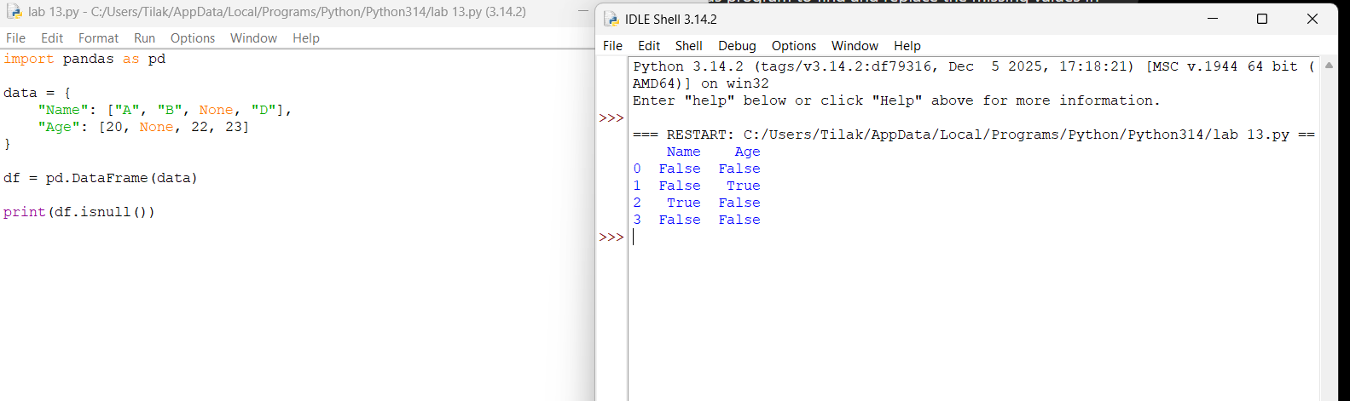

14. Pandas program to find and replace the missing values
import pandas as pd

data = {
"Name": ["A", "B", None, "D"],
"Age": [20, None, 22, 23]
}

df = pd.DataFrame(data)

df["Name"].fillna("Unknown", inplace=True)
df["Age"].fillna(df["Age"].mean(), inplace=True)

print(df)
Output:
Name Age
0 A 20.000000
1 B 21.666667
2 Unknown 22.000000
3 D 23.000000
